Hexagon Conquest Game Report
Introduction
Hexagon Conquest is a turn-based strategy game where two players compete to dominate a 12x12 hexagonal board. Players move their monsters across the board, claiming hexagons as they go. The game ends when all hexagons are claimed, and the player with the most hexagons wins. This project was inspired by classic board games and is designed for casual gamers.

Game Mechanics
Objective:
- The objective of this game is for each player to conquer as many hexagons as possible. The player who has the most hexagons and has no room to dominate more hexagons wins the game.
Setup:
- Each player starts with a monster at opposite corners of the board.
Turns: Players take turns moving their monster to adjacent hexagons, which are then claimed for their territory.
This what the game looks like when starting:
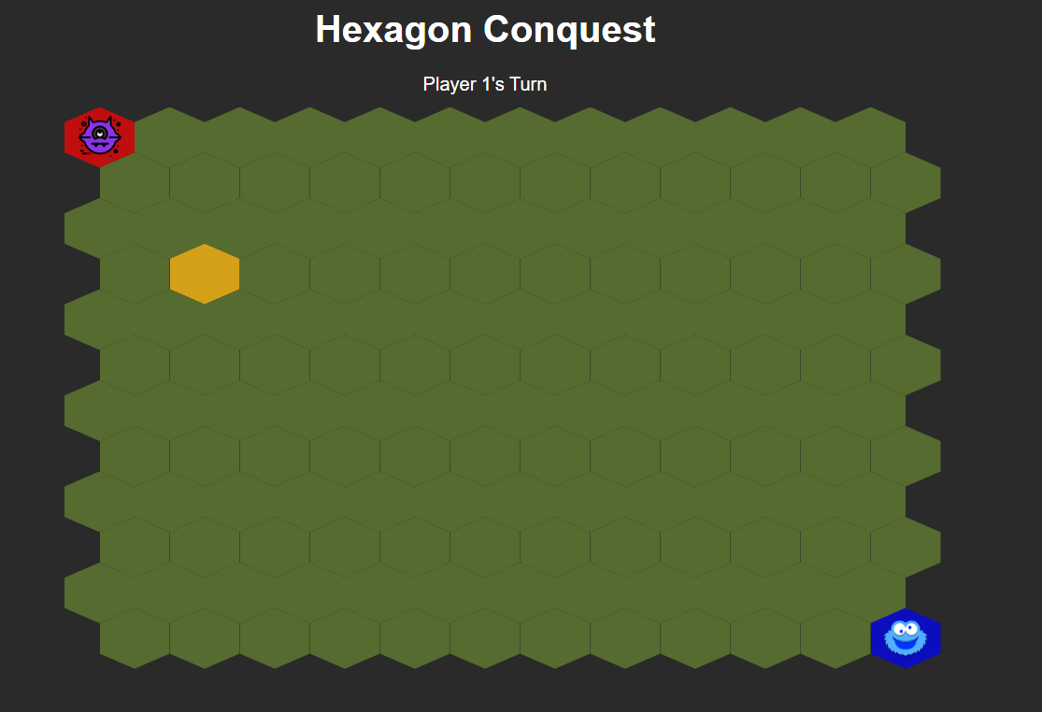

Development
Challenges:
- One challenge I faced was making the hexagon into a honeycomb. I did the hexagon by researching coding sites and AI. But mainly to align each other with no space AI helped a lot.
This was one of the screenshots I took for the development process, you can see the hexagon wasn’t aligned the way I liked. But in the end, I managed to get it fixed.
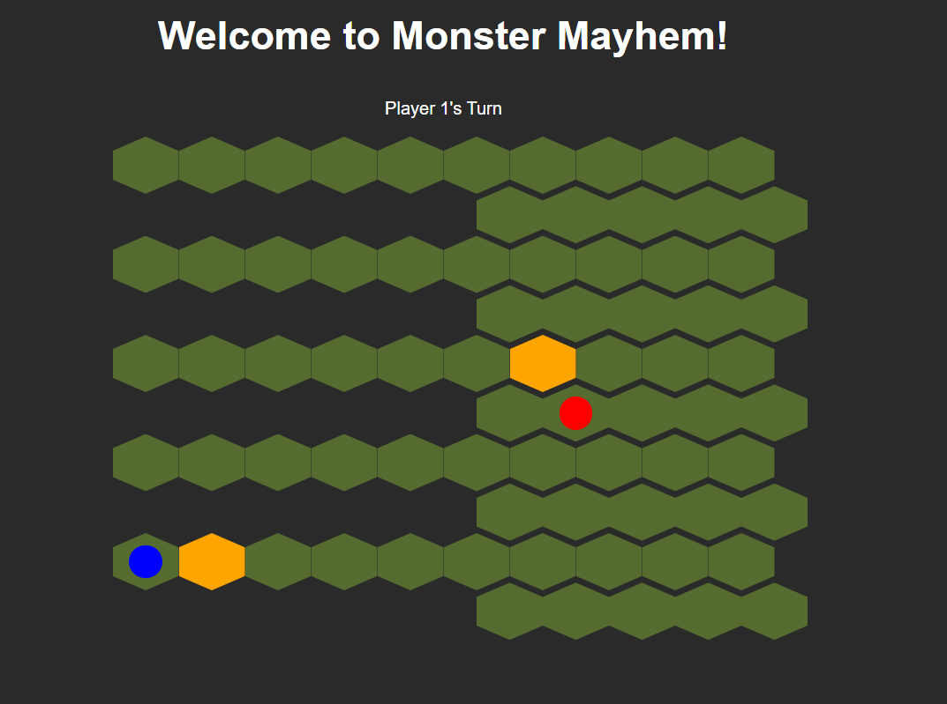

- Another challenge I faced was adding images and making them dominate the hexagon. I had no idea how to start with AI, but it helped me a lot. The above shows a bit the red and blue dots were supposed to be monsters, but I was still researching how to attach the image to it.

- The last challenge I faced was committing to GIT. I had to do a lot of commits due to tests and getting errors, so it was good practice but very time-consuming.

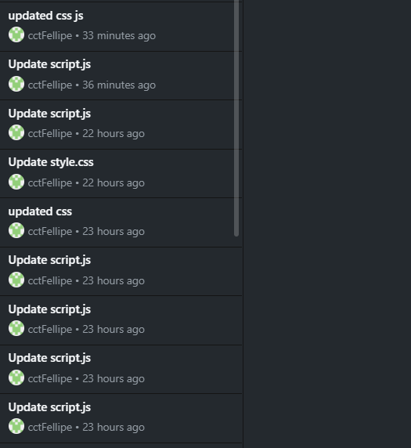
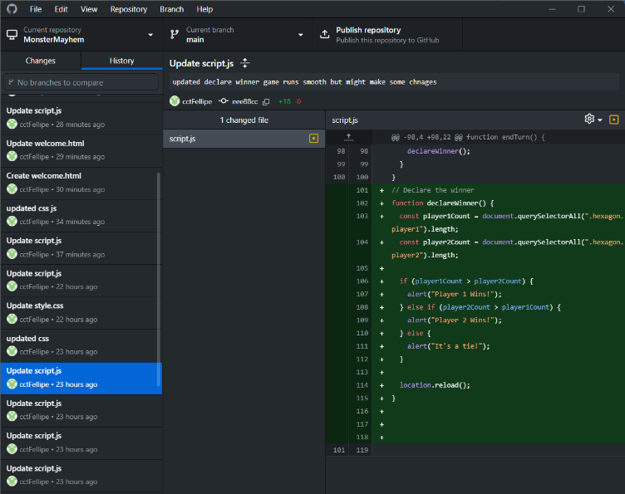
This is some of the commits I made.

AI-Generated Code
Usage:
- AI was used to generate logic and style some text. I mainly used it for stuff I didn’t know for example positioning, the logic behind movement, aligning hexagons with no spaces, etc.AI was a very good help to me, without I think I wouldn’t be able to do it.
Conclusion
- This project enhanced my skills in JavaScript, CSS, and grid-based layouts. It also taught me the importance of version control with GitHub. I plan to refine the game further by adding animations and improving the UI.

